Name: Mohamad Haziq Zikry Bin Mohammad Razak

Matrics Number: A20EC0079

Question 1

*// Program 6.5*

#include <iostream>

#include <iomanip>

using namespace std;

int main(){

    int n;

    float f;

    double d;

    char s[100];

    cout << "input one integer: ";

    cin >> n;

    cout << n << endl;

    cout << setw(6) << n << endl;

    cout << setw(-6) << n << endl;

    cout << "Input one string: ";

    cin >> s;

    cout << s << endl;

    cout << setw(20) << s << endl;

    cout << left << setw(20) << s << endl;

    cout << "Input one floating number: ";

    cin >> f;

    cout << fixed << f << endl;

    cout << "Input one double number: ";

    cin >> d;

    cout << d << endl;

    cout << setprecision(2) << d << endl;

    cout << setw(10) << setprecision(2) << d << endl;

    return 0;

}

Sample output

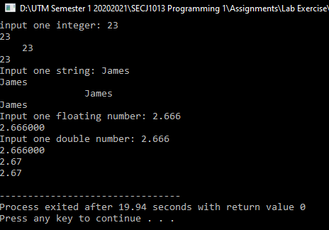

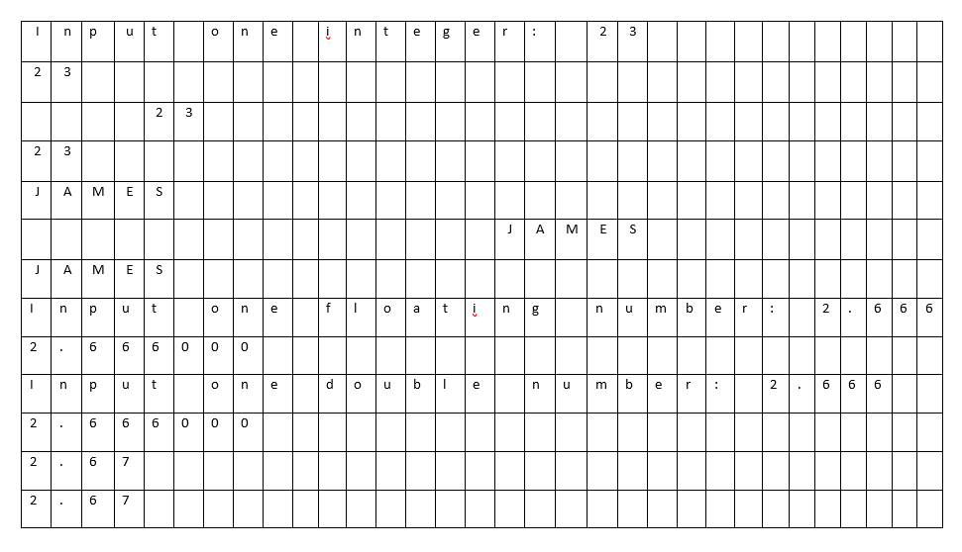

2. Type in Program 6.6 as follows:

*//Program 6.6*

#include <iostream>

#include <fstream>

using namespace std;

int main ()

{

    float val1, val2, val3, val4;

    ifstream inData;

    ofstream outData;

    inData.open ("DataIn.txt");

    outData.open ("DataOut.txt");

    inData >> val1 >> val2 >> val3 >> val4 ;

    outData  << val4 << endl ;

    outData  << val3 << endl ;

    outData  << val2 << endl ;

    outData  << val1 << endl ;

    return 0 ;

}

a.Create the input data file DataIn.txt. The file consists of the following data:

5.5

6.6

7.7

8.8

b. Compile and run Program 6.6. Examine the results carefully. Understand what each line of the segment in the program does. In your own words, explain what the program does.

In the program, the line 3 header is used for both either input or output files. ifstream is used for input only and file cannot be written to and the open will fail if file does not exist . ofstream is used to open for output only and file cannot be read from. A file with be created if no file exists. Both ifstream and ofstream uses the open() member function such as in line 12 and 13 of the program. The input data file created will output in the output data file according to the program. ta type for both input, output files.

c. Modify the program so it also outputs the average of the four input numbers

*//Program 6.6*

#include <iostream>

#include <fstream>

using namespace std;

int main ()

{

    float val1, val2, val3, val4;

    float average ;*// initialize for average*

    ifstream inData;

    ofstream outData;

    inData.open ("DataIn.txt");

    outData.open ("DataOut.txt");

    inData >> val1 >> val2 >> val3 >> val4 ;

    average = (val1 + val2 + val3 + val4)/4 ;*// average formula*

    outData  << val4 << endl ;

    outData  << val3 << endl ;

    outData  << val2 << endl ;

    outData  << val1 << endl ;

    outData << average << endl ;*// outputs the average*

    return 0 ;

}

d. Modify the program by changing file data types in line 9 and 10 to fstream data type.

fstream inData;

    fstream outData;

    inData.open ("DataIn.txt",ios::in);

    outData.open ("DataOut.txt", ios::out);

Question 3

1. Ouput

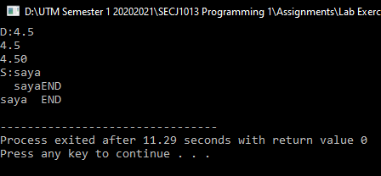

|  |  |  |  |  |  |  |  |  |
| --- | --- | --- | --- | --- | --- | --- | --- | --- |
| D | : | 4 | . | 5 |  |  |  |  |
| 4 | . | 5 |  |  |  |  |  |  |
| 4 | . | 5 | 0 |  |  |  |  |  |
| S | : | s | a | y | a |  |  |  |
|  |  | s | a | y | A | E | N | D |
| s | a | y | a |  |  | E | N | D |

1. Output

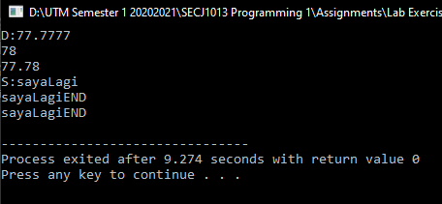

|  |  |  |  |  |  |  |  |  |  |  |
| --- | --- | --- | --- | --- | --- | --- | --- | --- | --- | --- |
| D | : | 7 | 7 | . | 7 | 7 | 7 | 7 |  |  |
| 7 | 8 |  |  |  |  |  |  |  |  |  |
| 7 | 7 | . | 7 | 8 |  |  |  |  |  |  |
| S | : | s | a | y | a | L | a | g | i |  |
| s | a | y | a | L | a | g | i | E | N | D |
| s | a | y | a | L | a | g | i | E | N | D |

Question 4

a. Show the output sent to the file named hasil.txt.



b. Show the output sent to the file named lapor.txt.

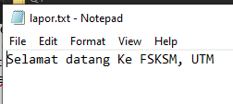

c. Show the output displayed on the screen.

